**Magento Known Issues**

**Issues**

1. **Reset Magento 2 admin password**
   * Problem: when customer forget the admin password (or) need to reset the admin password
   * If you want to replace the old password to new password, you have 2 ways to set or change the password

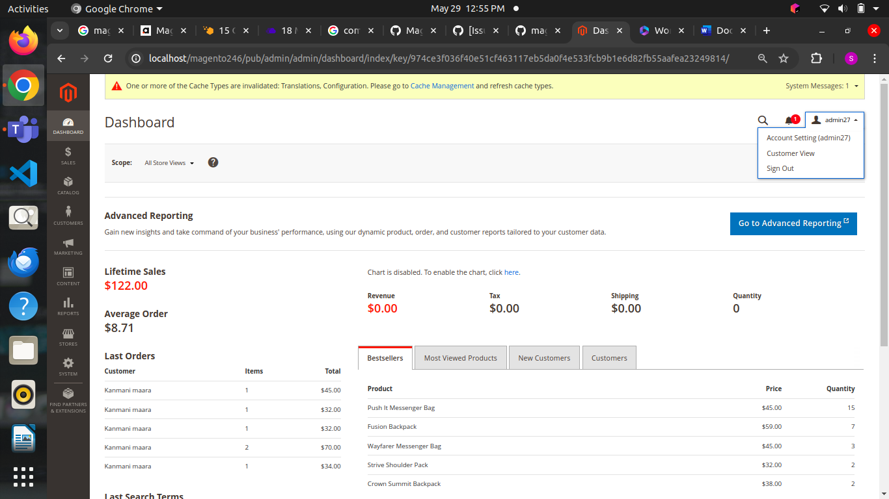

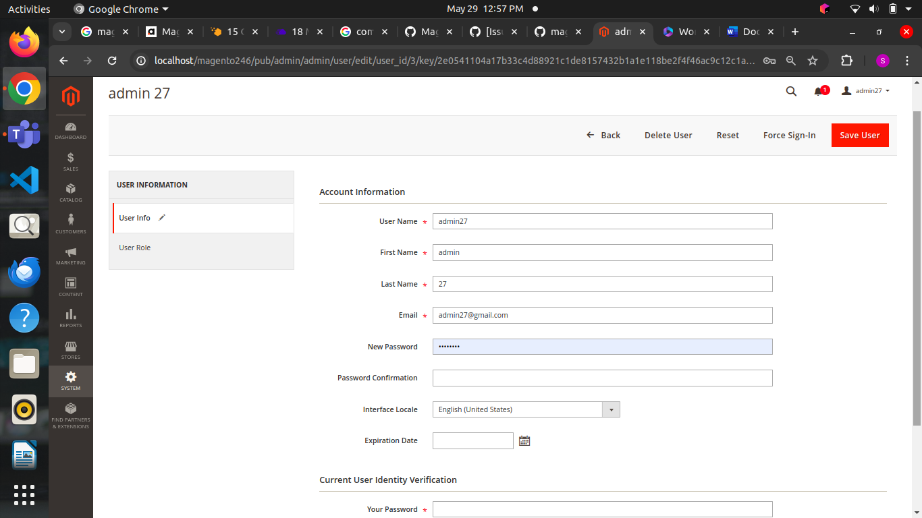

* + If you remember your old password, you can use this method add new password in the new password tab and save the details



* + In Magento admi panel system->permission->all users
  + In that open the current user and change the new password here also and click save the password will be replaced

**Another method:**

* + This method is used when the user does not remember their current password, they can use this method
  + In this method we are having 3 types of ways

**Method 1: Reset Magento admin password using default recovery system**

* + Go to Admin Panel -> Click Forgot Passwords
  + Fill in the email address you registered with your Magento account and click Retrieve password
  + Go to your email and open the password reset link. Enter a new password and click Reset.

**Method 2: Recover Password Using Magento Command Line**

* + php bin / magento admin: user: create –admin-user = admin –admin-password = admin123

**Method 3: Change password from MySQL Manager or phpMyAdmin**

* + Go to MySQL Manager or phpMyAdmin, go to the Magento 2 website database, and find the admin**_**user table.
  + You can then change your password to MD5 by running the following command.
  + UPDATE `admin_user` SET `password` = MD5('PASSWORD') WHERE `username` = 'USERNAME';

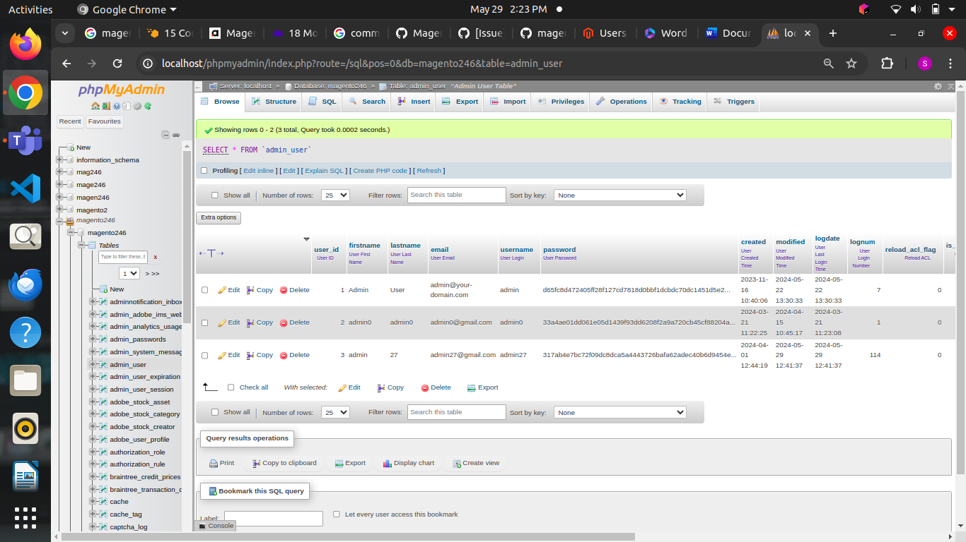

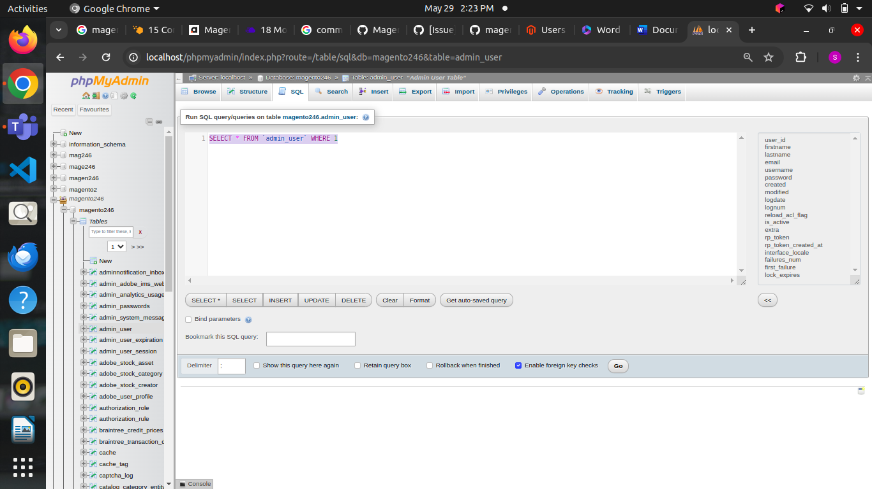

* + Give the command line in this sql query space

2) **Flat Catalog Not Enabled**:

* Problem:Magento uses flat tables to speed up product and category queries by merging attributes into a single table. If not enabled, performance can be slow.
* Log in to the Magento Admin.
* Navigate to Stores > Configuration > Catalog > Storefront.
* Set both "Use Flat Catalog Category" and "Use Flat Catalog Product" to "Yes".
* Save the configuration and clear the cache.
* Check the result
* Changed the product name and added demo category

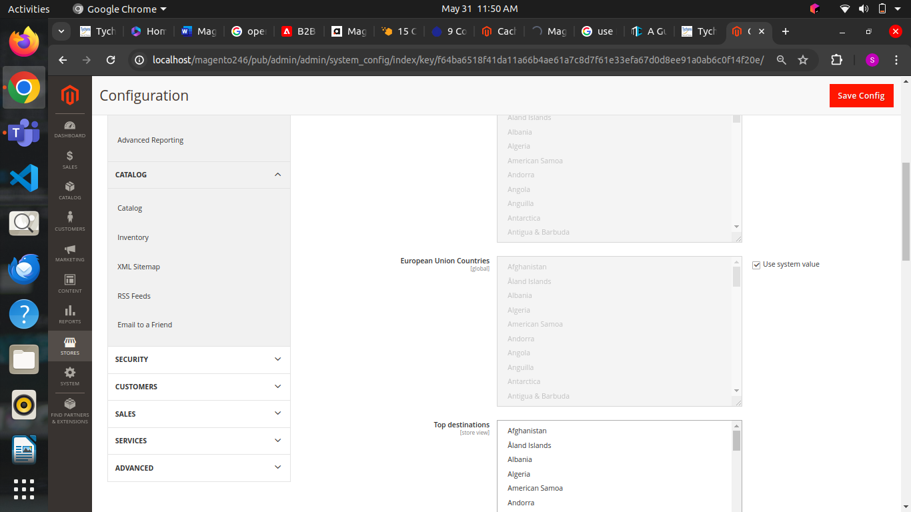

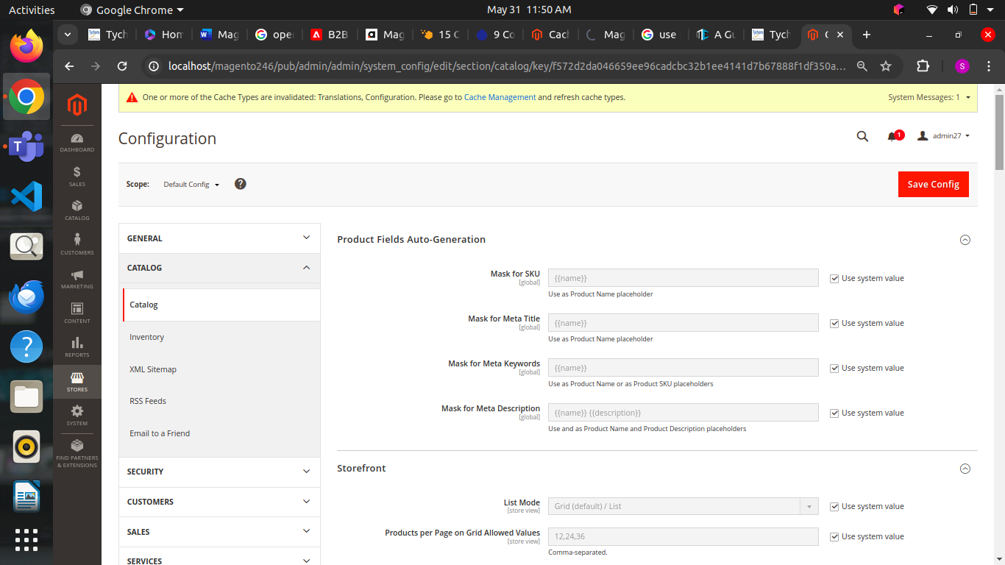

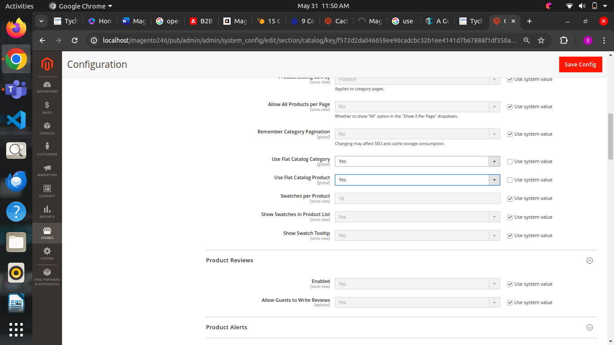

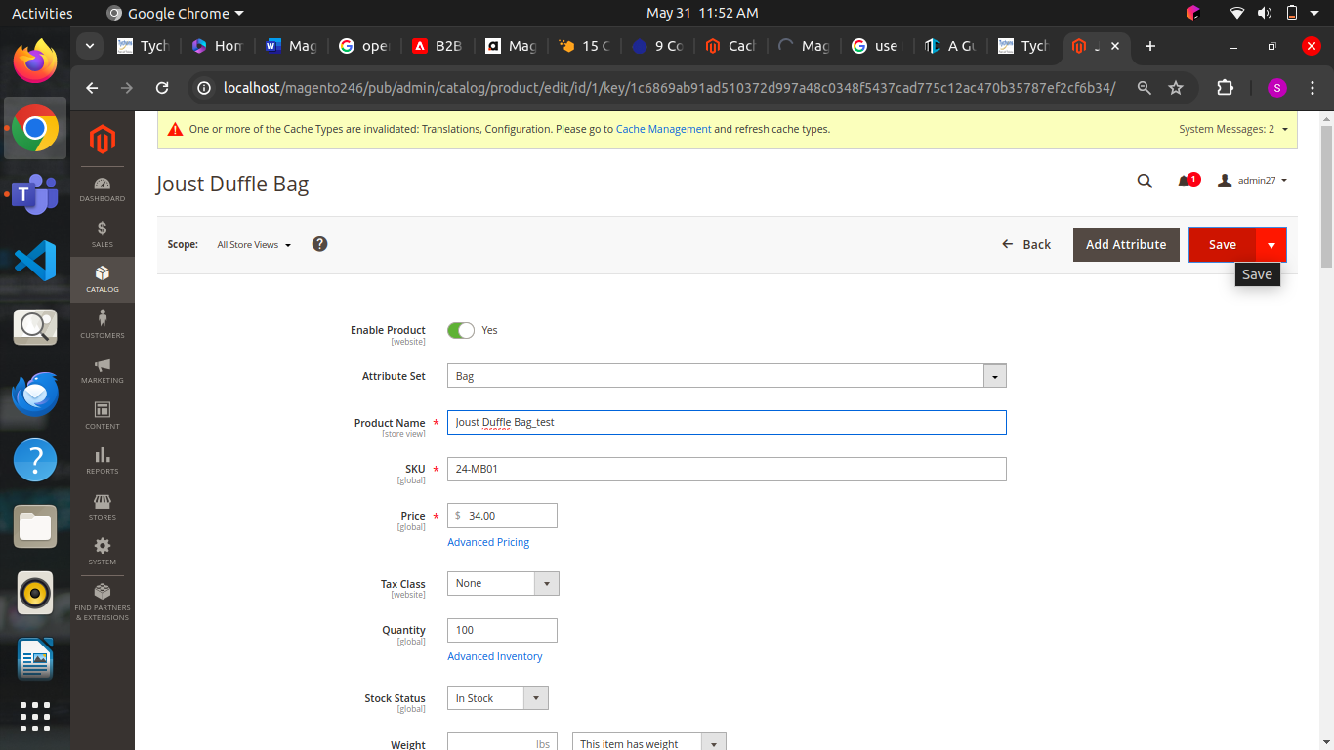

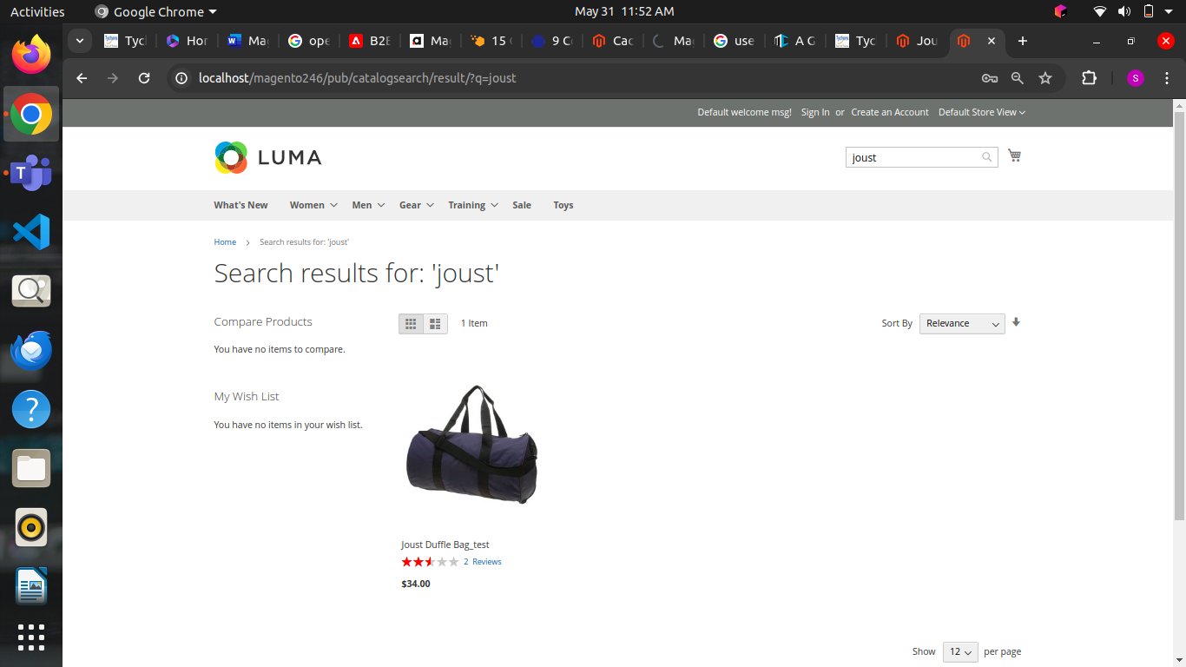

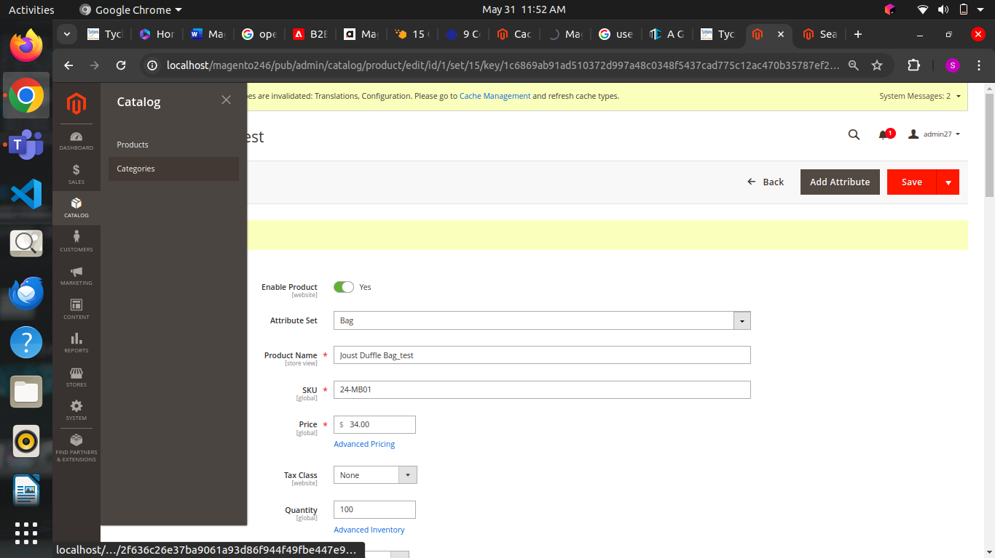

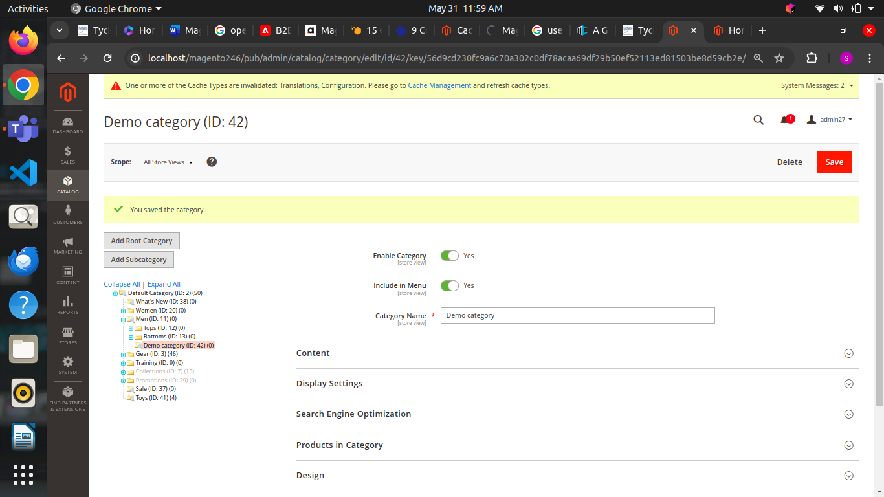

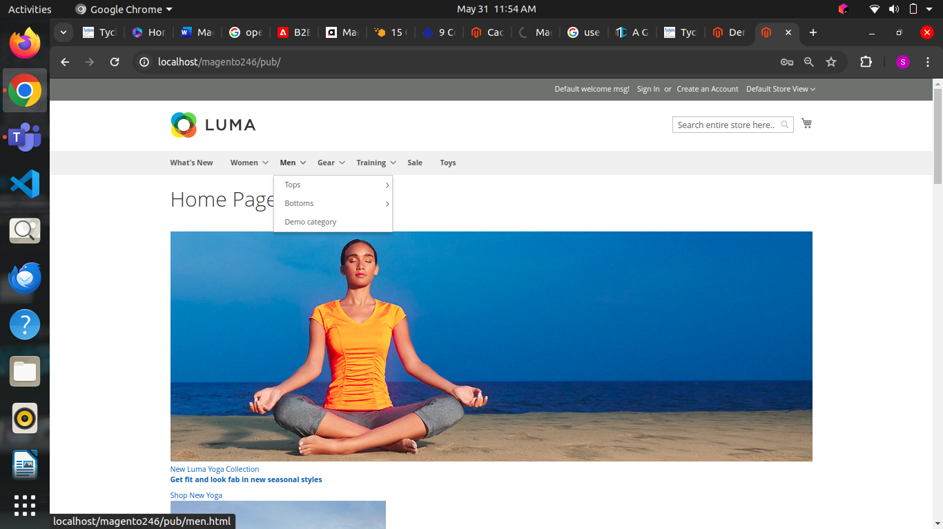

3) **Developer Mode Not Enabled:**

* Problem: Developer mode helps in debugging and is essential during development or troubleshooting.
* Access the server via SSH.
* Navigate to the Magento root directory.
* Run the command: php bin/magento deploy:mode:set developer.

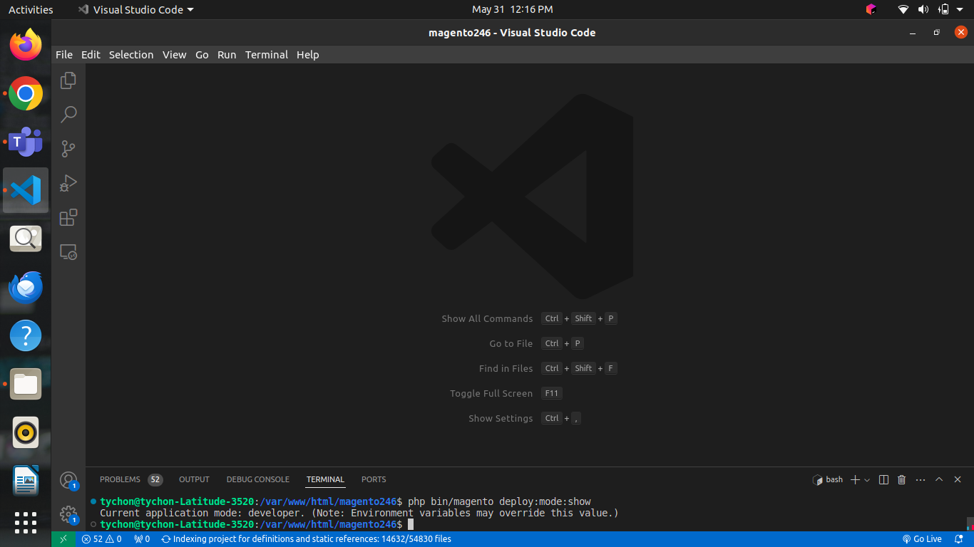

4) **Issue in role assigning to the new users**

* Problem: While creating a new user from the Magento Admin section, you might assign the wrong role or decide the insufficient permissions in the application.
* This issue is managed by redirecting to the Magento Admin and resetting the resources
* Redirect to System > Permissions > All Users
* Click on the All Users option
* Choose any User > User Roles and update the permissions
* Click on Save

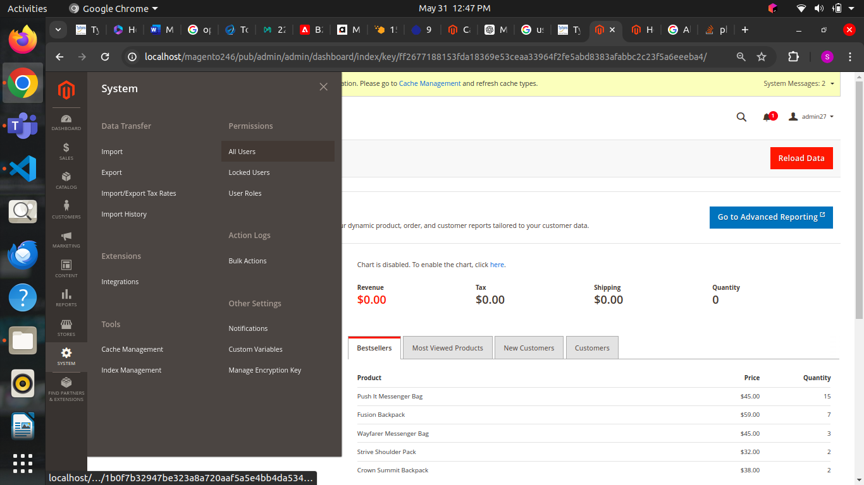

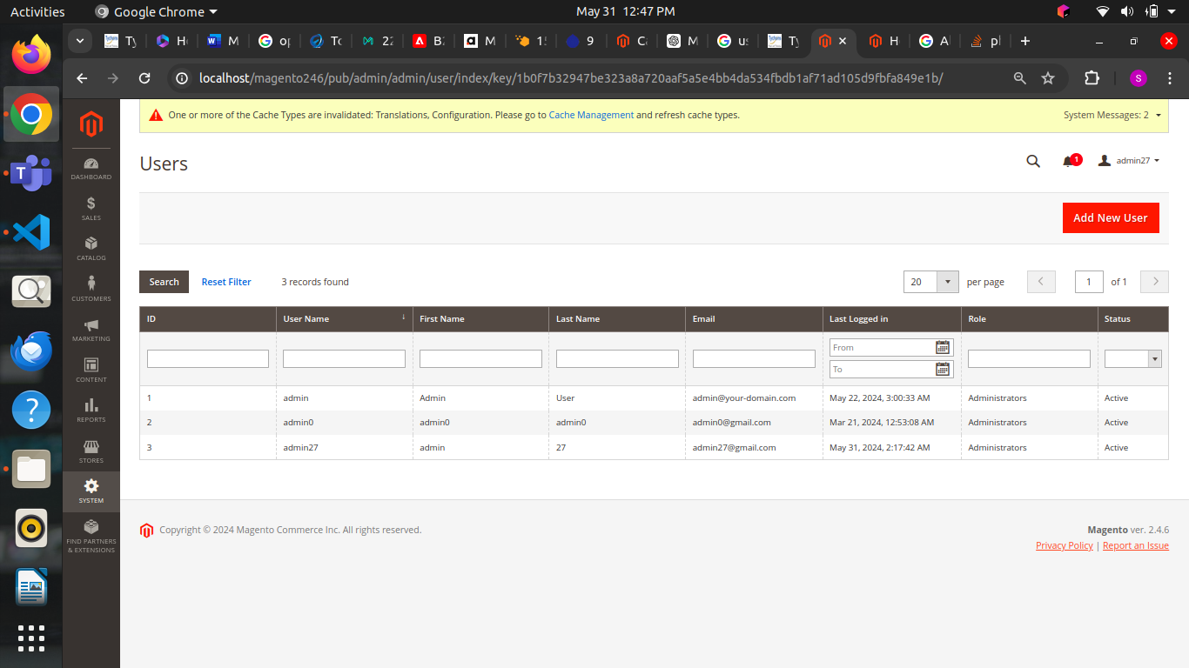

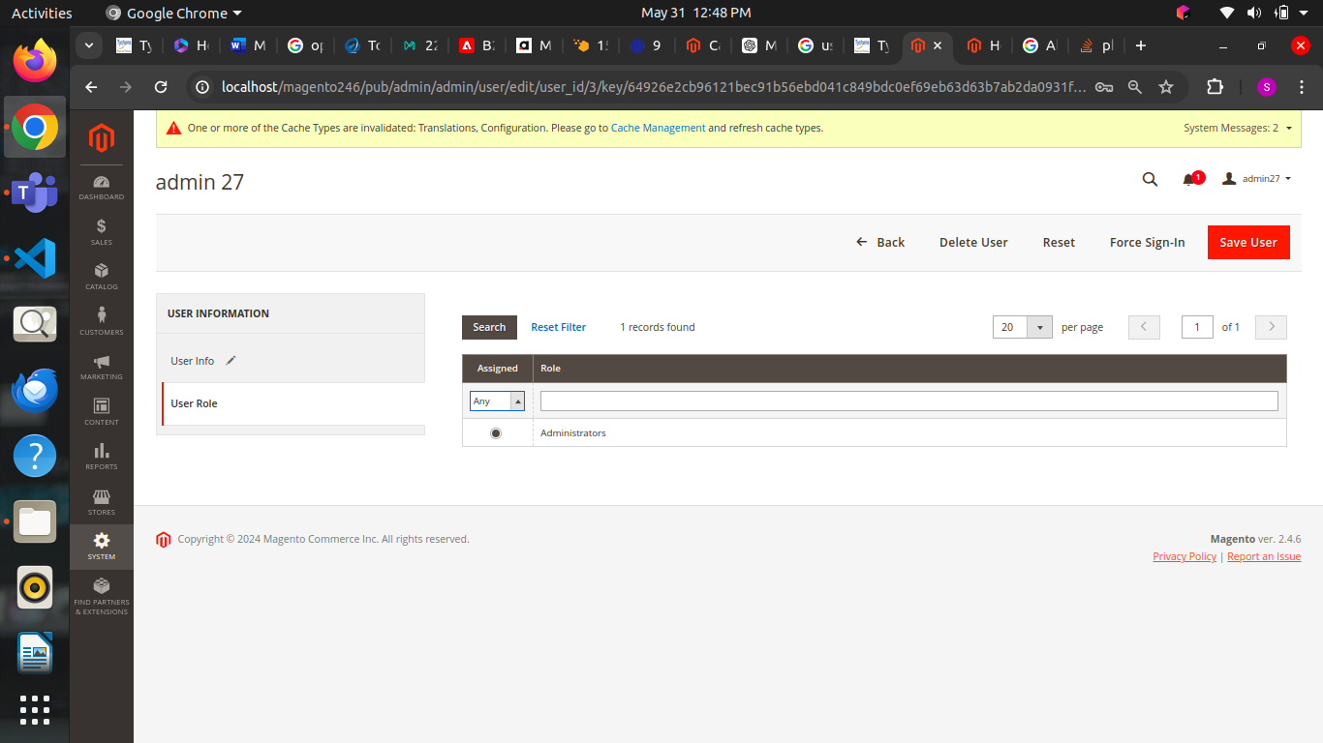

5) **Issues in javascript and css file**

* Problem: Most visitors come to the website and leave due to the higher loading speed.
* There are many components, but JavaScript and CSS are important factors that require attention.
* It is important to reduce the JavaScript and CSS files by merging them into a single file.
* This will remove the line breaks and extra space in the coding and create continuous lines of text.
* Log in to the Magento 2 Backend and redirect to Stores > Configuration > Advanced > Developer
* open the JavaScript Settings and enable the option Merge JavaScript files
* Save the configuration
* Flush Cache at System > Cache Management
* Optimizing the JS and CSS results in faster loading the web pages, and you can also consider having experts handle Magento 2 Issues.

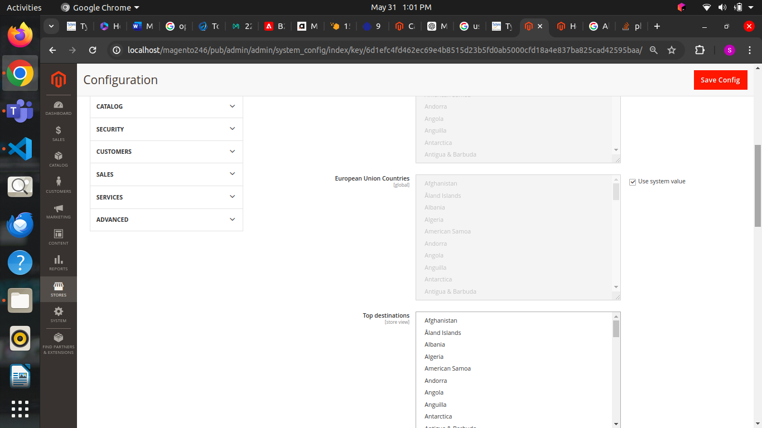

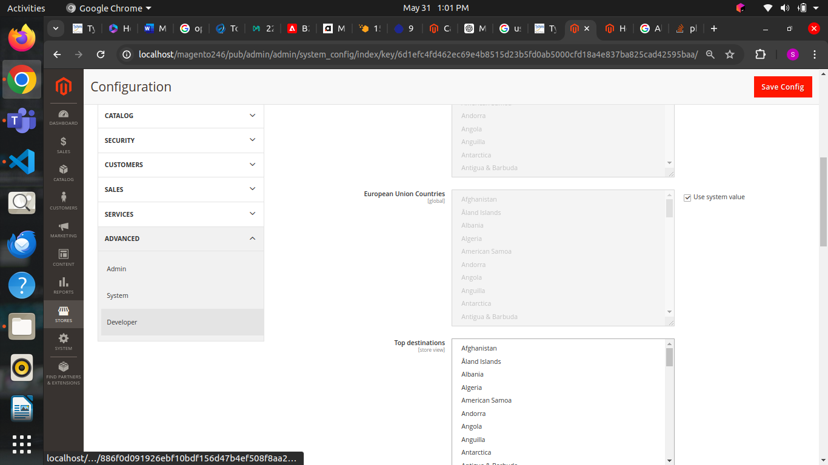

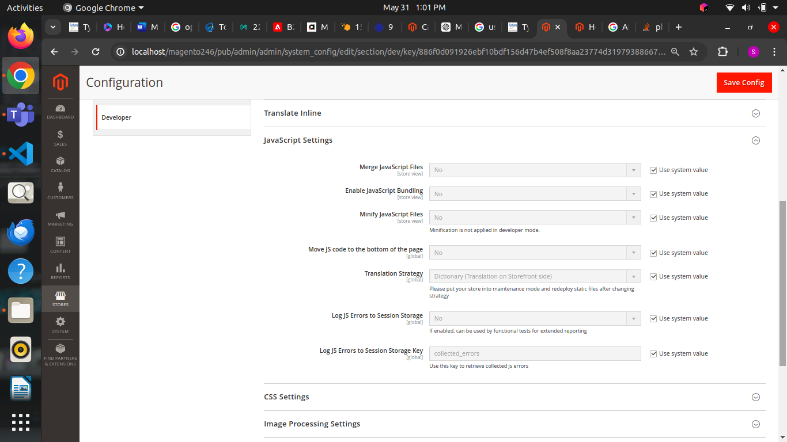

**6)Managing the cache**

* Problem: The cache stores all the information about browsing information to deliver the content that is loaded faster and improves the website speed.
* It is important to clear the cache in case you make any UI changes.
* Following the below steps to clear the cache to resolve Magento 2 issues:
* Log in to your Magento Admin section
* Redirect to System > Tools > Cache Management
* Choose the Cache Type that you plan to activate
* Choose Enable in the Actions dropdown and click on Submit
* Flush Static Files Cache

